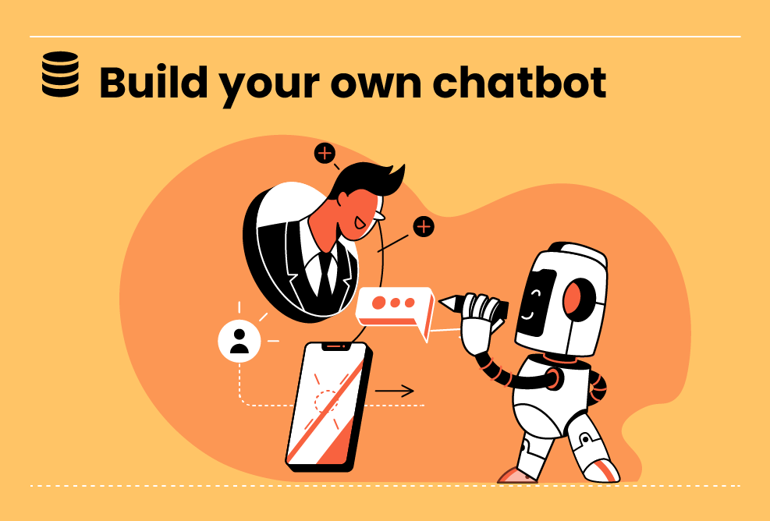

All Levels

**Natural Language Processing ChatBot with NLTK for Text Classification**

This project will teach you how to create a natural language processing chatbot with NLTK for text classification. You will learn how to import the necessary NLP libraries, preprocess the text data, create a feature vector for each text document, train a machine-learning model on the feature vectors, and use the trained model to classify new...

Worked on this project

Duration : 10 Hours

All Levels

4 Steps

**Project Objective**

This project aims to create a natural language processing chatbot with NLTK for text classification. The chatbot should be able to classify text into different categories, such as "technical support," "billing," or "shipping."

**Inspiring Project Examples**

<https://www.nltk.org/book/ch01.html>

**Step By Step**

On this project, you will pass by these steps. All steps must be done to successfully complete this project.

**Natural Language Processing Techniques for Text Classification**

Natural Language Processing (NLP) Is A Technique Used To Process Human Language. In This Project, We Will Implement Several NLP Techniques For Text Classification Using Python's Natural Language Toolkit (NLTK). The Techniques Include Tokenization, Stopword Removal, Tagging, Lemmatization, And Stemming.

**Decision Tree and Naive Bayes Classifiers for Text Classification**

After Implementing NLP Techniques, We Will Build A Model Using Two Popular Classifiers - Decision Tree And Naive Bayes. Decision Tree Classifier Creates A Tree Where Each Node Is A Feature Name, And Each Branch Defines The Feature Value. Naive Bayes Is A Simpler Algorithm That Sets A Basic Baseline Accuracy Model.

**Hyper Parameter Tuning**

After Building The Initial Models, We Will Fine-Tune Them By Adjusting Hyperparameters. Hyperparameters Are Configuration Variables That Determine The Behavior Of The Algorithms. This Project Will Focus On Tuning Two Hyperparameters - Entropy Cutoff And Support Cutoff.

**Performance**

You Should Explain What NLP Is, How It Can Be Used To Create Chatbots, And How NLTK Can Be Used For Text Classification.

**Instructor Guideline**

General Instructions for Students: Follow the instructions in the project guide. Use the resources listed below to help you complete the project. Ask questions if you get stuck.

**Guidelines Ressources**

https://youtu.be/QpzMWQvxXWk